Asia-China-Coin-3-Spade-Flat Handle-Arch Foot-H H 3.xx, R 7

长安方足布,"ChangAn"Spade-shape Coin."长安",place of the Zhao Nation.Some other people insisted that,the "ChangAn" Spade Coin should belong to Han Nation,Warring Stateas Period.

Length 4.2CM/1.65Inches, width 2.6CM/1.02Inches

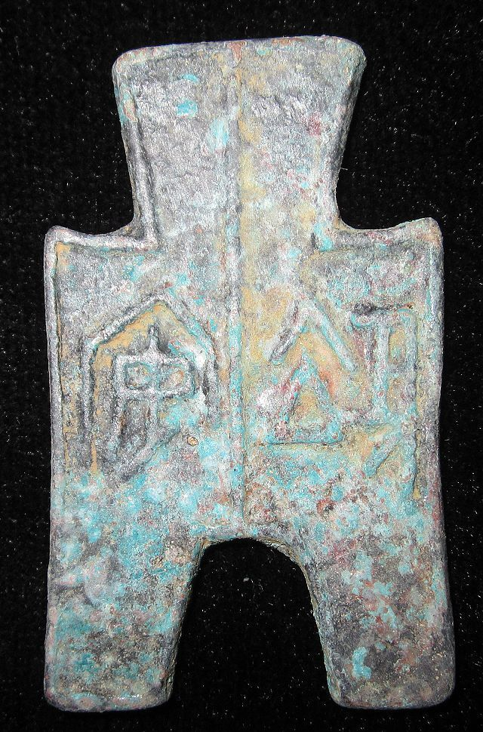

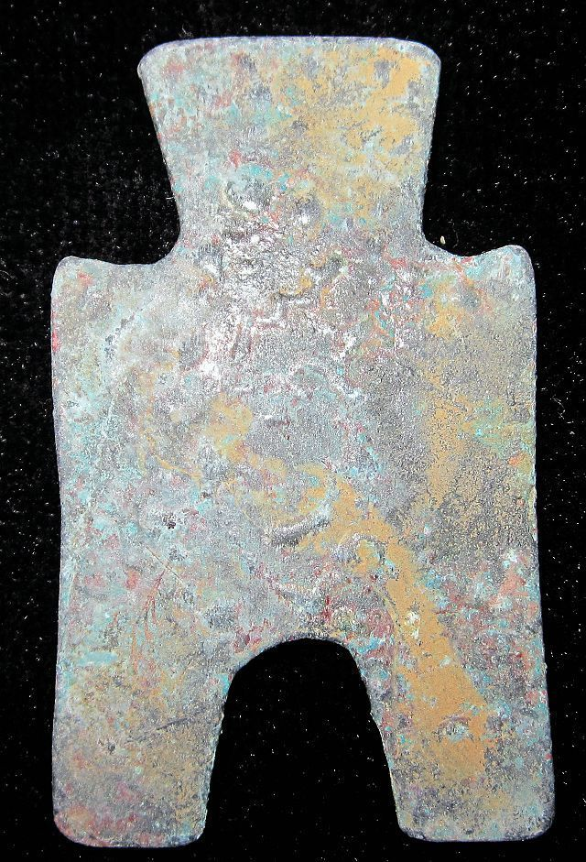

### You won this auction. | [View order details](http://payments.ebay.com/ws/eBayISAPI.dll?ViewPaymentStatus&transid=0&ssPageName=STRK:MESO:VPS&itemId=251417572748)

|  |  |  |
| --- | --- | --- |
| Details about  WarringStatesPeriod ZHAO HAN NATION CITY MINT MONEY BRONZE SPADE COIN长安方足布1.65" [See original listing](http://www.ebay.com/itm/WarringStatesPeriod-ZHAO-HAN-NATION-CITY-MINT-MONEY-BRONZE-SPADE-COIN-1-65-/251417572748?nma=true&si=5L4Tlo08dyY9pQflhUEb6fWvMTI%253D&orig_cvip=true&rt=nc&_trksid=p2047675.l2557) | | |
| |  |  | | --- | --- | | |  | | --- | |  | | |  |  |
|  |  |
| Item condition:  --not specified  “Rust on the body,Museum quality” |  |
| Ended:  Jan 10, 2014 19:07:49 PST |  |
| Winning bid:  US $34.00  [ [4 bids](http://offer.ebay.com/ws/eBayISAPI.dll?ViewBids&_trksid=p2047675.l2565&rt=nc&item=251417572748) ] |  |
| Shipping:  $10.00 Economy Shipping from outside US |  |
| Item location:  GuangZhou, China |  |
| Seller:  [bcculture](http://myworld.ebay.com/bcculture?_trksid=p2047675.l2559) ([84](http://feedback.ebay.com/ws/eBayISAPI.dll?ViewFeedback&userid=bcculture&iid=251417572748&ssPageName=VIP:feedback&ftab=FeedbackAsSeller&rt=nc&_trksid=p2047675.l2560) )  |  [Seller's other items](http://www.ebay.com/sch/bcculture/m.html?item=251417572748&rt=nc&_trksid=p2047675.l2562) |  |